HSN

Hsn Tax is the tax structure which is imposed by Indian Government. All the tax details are released by the Indian Government and this below page show the UI of all those HSN Taxes.  
  
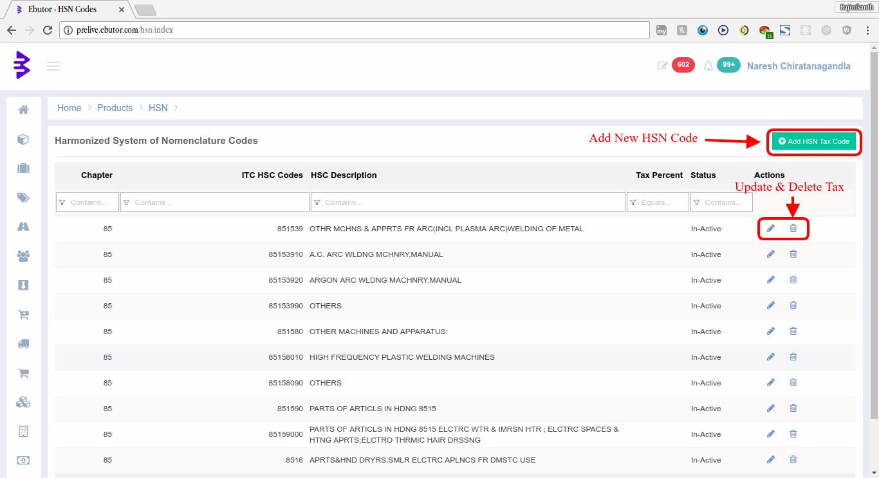  
  
**Add New HSN Tax:** To add new HSN Tax  
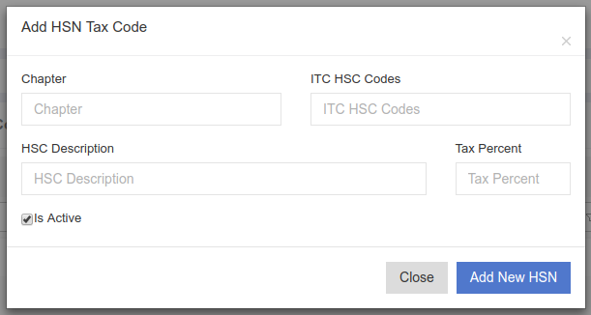

**Edit HSN Tax:** To edit and update the HSN Tax Record  
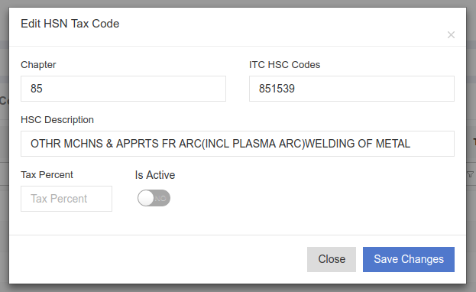  
**Delete HSN Tax:** To delete HSN Tax record with a javascript confirm box.  
  
Code Details:  
Module Name: **HSN**URL: <https://portal.ebutor.com/hsn/index>  
Database: **HSN_Master** table  
Feautres:  
 View HSN Page Permission [HSN000]  
 Add HSN Tax Permission [HSN001]  
 Edit HSN Tax Percentage Permission [HSN0021]  
 Edit HSN Tax Data Permission [HSN0022]  
 Edit HSN Tax Permission [HSN002]  
 Delete HSN Tax Permission [HSN003]